**Physics Stage 2: Nuclear Physics Test 2014**

Name: _________________________________________________ (46 marks)

1. Within a nuclear reactor, uranium-235 is bombarded by a neutron to split into two daughter products also emitting two neutrons. Part of the nuclear equation is shown below.



* 1. Write the nuclide for the missing daughter product labelled **X**. 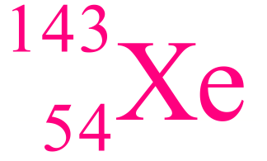

(1 mark)

* 1. What is the atomic and mass numbers of the daughter product

Atomic number 54 Mass number 143 (1 mark)

1. Explain why beta radiation has greater penetration than alpha radiation (e.g. thorough air or paper). (3 marks)

Alpha has higher charge [1]

Alpha has high mass [1]

Thus interacts more with other atoms [1]

Loses K.E./velocity faster than beta until absorbed [1]

(any 3 out of the 4 above to required to gain 3 marks)

1. A radioactive isotope has a count of 3.85 x 103 decays in one hour. Calculate the activity of the source and report your answer in the appropriate SI unit. (2 marks)

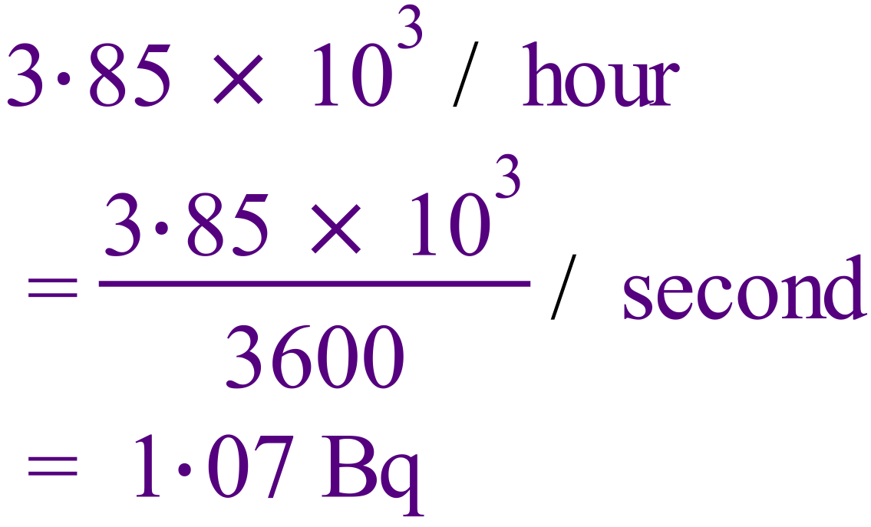

1. Food can be preserved by irradiating it with nuclear gamma radiation. Meat typically requires an equivalent dose of 1000 Gy to sterilize it. How much energy does 2.0 kg of meat absorb when it undergoes sterilization? (2 marks)

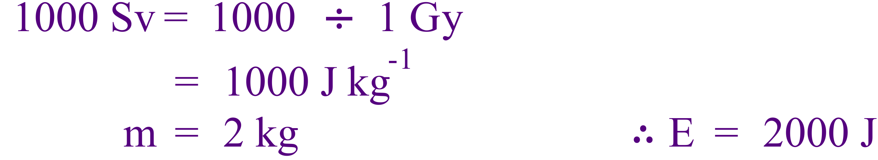

1. Calculating the binding energy per nucleon **in MeV** of the helium-3 atom given the mass of   
   He-3 = 5.00 x 10-27 kg. (5 marks)

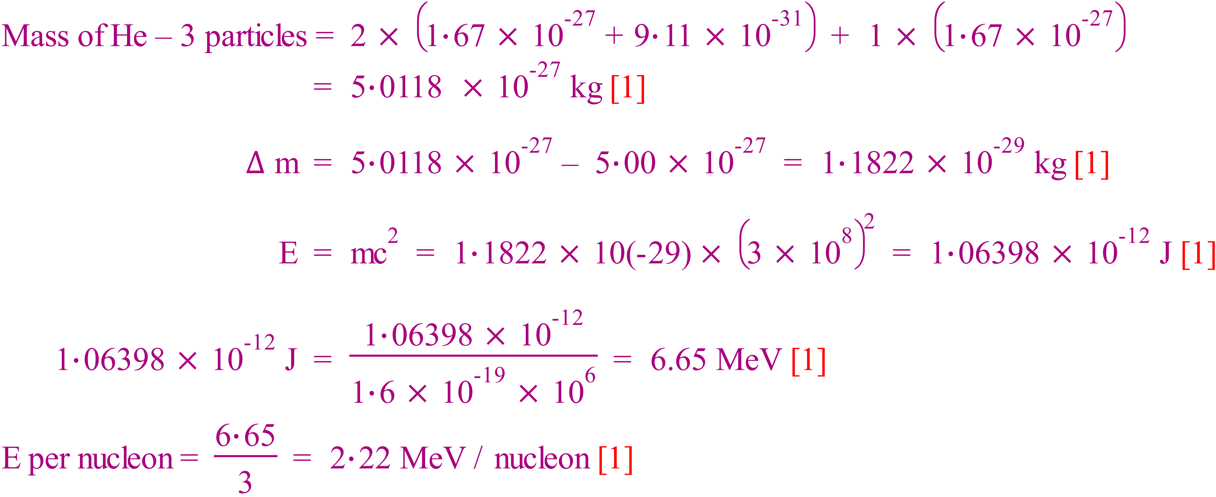

1. Uranium-238 decays via alpha emission to thorium-234.
   1. Write the reaction down a balanced equation for this reaction. (1 mark)



* 1. Calculate the energy released from the decay of one atom. (3 marks)

You may need the following information:

Mass of U-238 atom: 238.05079 u

Mass of α particle: 4.00260 u

Mass of Th-234 atom: 234.04360 u

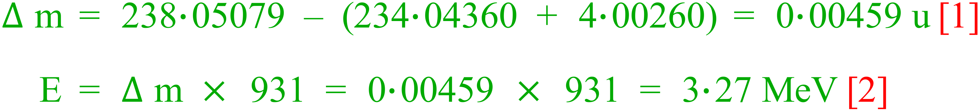

* 1. Define what is meant by the ‘binding energy’’ of a nucleus? (2 marks)

Binding energy is the energy equivalent of the mass defect. [1]

Then at least one of the following:

Mass defect is the difference in the mass of an atom and the sum of its parts [1]

The work necessary to separate an atom into it's constituent particle [1]

The work required to overcome the nuclear forces that bind an atom together [1]

The chart below shows the binding energy per nucleon as a function of nucleon number.

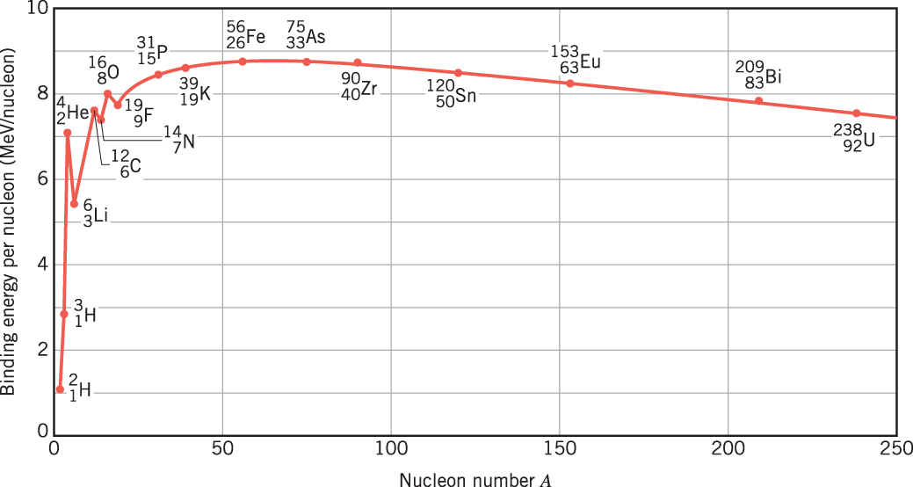

* 1. Write down 2 different atoms above which could – at least in theory – be possible fuel sources for nuclear fission reactors? (1 mark)

Any two atoms to the right of As (not including As), must have two to gain mark.

* 1. Explain why the atoms you nominated are suitable for fission, but others in the chart above are not. (2 marks)

Atoms of mass number similar to iron are energetically most favourable. [1]

Then at least one of the following:

Therefore larger atoms like U will give up energy when split to form smaller fragments closer to Fe in mass number and therefore can provide fuel for a fission reactor. [1]

Or

Therefore large atoms tend to fission to become closer to Fe, whilst smaller atoms tend to fuse. [1]

1. The forming of a new element during radioactive decay is called transmutation. Explain why emitting alpha and beta radiation causes a transmutation but emitting gamma radiation does not. (3 marks)

Alpha emission involves the loss 2 proton [½]

Beta emission involves change on one neutron to a proton [½]

In both cases change in proton number occurs, hence change in atomic number (element). [1]

This is not the case with gamma [1].

1. Determine the half-life of the substance from the graph.
   1. Half-life = 15 days (1 mark)
   2. Use this half-life to calculate as accurately as possible the expected activity of the sample after 63 days. (2 marks)

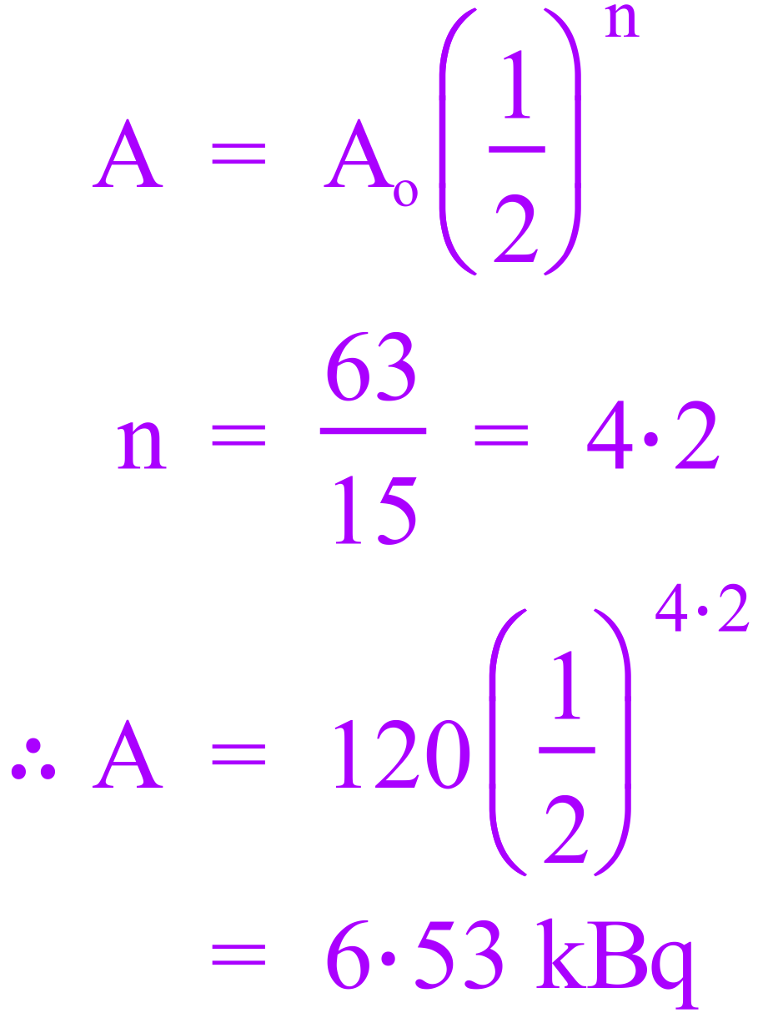0020

1. A miner in a uranium mine does not know that he is exposed to a radon-222 gas leak. The gas is an alpha emitter, and it has a very long half life. The gas he breathes in is not eliminated from the body as it settles into the tissue of his lung. The radon in his body has an estimated activity of 3.40kBq which can be considered constant. Each decay of the isotope releases 3.8 x 10-12 J of energy into his body. One month (30 days) later, the accident is discovered, and management realise that he has been exposed to the gas.
2. Calculate the total energy the miner absorbed into his lungs during the 30 days since he breathed in the radon. (2 marks)

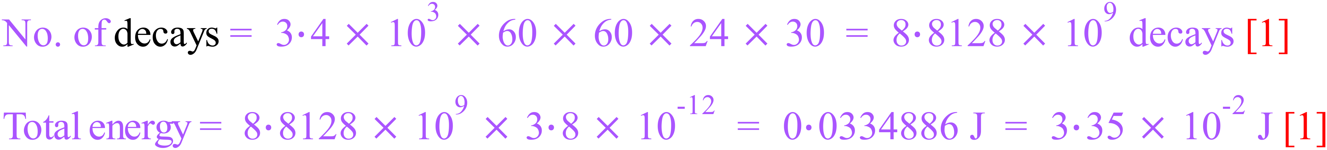

1. Calculate the absorbed dose he received in one month if he has a mass of 75 kg. (If you were unable to obtain a value for (a) above use 0.035 J) (2 marks)

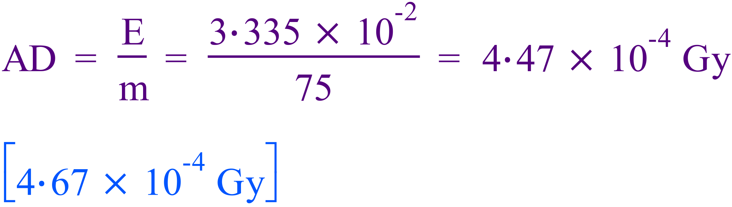

1. Calculate the dose equivalent. (2 marks)

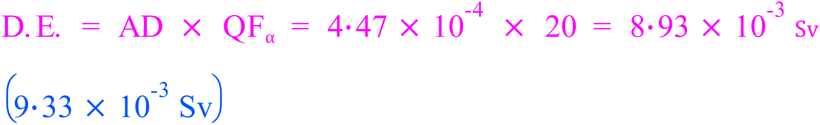

1. Should the miner be concerned about his exposure? Explain. (2 marks)

No [1], this is a very small amount of radiation and will almost certainly cause no harm [1].

**Comprehension: *Read the article then answer the questions.*** (10 marks)

#### THE BASICS OF NUCLEAR POWER

Nuclear power plants generate electricity from fission, usually of uranium-235 (U-235), the nucleus of which has 92 protons and 143 neutrons. When it absorbs an extra neutron, the nucleus becomes unstable and splits into smaller pieces and more neutrons. The products and neutrons have a smaller total mass than the U-235 and the first neutron; the mass difference has been converted into energy, mostly in the form of heat, which produces steam and in turn drives a turbine generator to produce electricity.

Natural uranium is a mixture of two isotopes, fissionable U-235 (0.7 per cent) and non-fissionable U-238. However, U-238 can absorb neutrons to form plutonium-239 (P-239), which is fissionable, and up to half the energy produced by a reactor can in fact come from fission of P-239. Some types of reactor require the amount of U-235 to be increased above the natural level, which is called enrichment. Pressurized water reactors (PWRs), the most common type of reactor, require fuel enriched to about 3 per cent U-235.

Reactor fuel is made up of fuel pellets or pins enclosed in a tubular cladding of steel, zircaloy, or aluminium. Several of these fuel rods make up each fuel assembly. The fast neutrons released in the fission reaction need to be slowed down before they will induce further fissions and give a sustained chain reaction. This is done by a moderator, usually water or graphite, which surrounds the fuel in the reactor. However, in “fast reactors” there is no moderator and the fast neutrons sustain the fission reaction.

A coolant is circulated through the reactor to remove heat from the fuel. Ordinary water (which is usually also the moderator) is most commonly used but heavy water (deuterium oxide), air, carbon dioxide, helium, liquid sodium, liquid sodium-potassium alloy, molten salts, or hydrocarbon liquids may be used in different types of reactor.

The chain reaction is controlled by using neutron absorbers such as boron, either by moving boron-containing control rods in and out of the reactor core, or by varying the boron concentration in the cooling water. These can also be used to shut down the reactor. The power level of the reactor is monitored by temperature, flow, and radiation instruments and used to determine control settings so that the chain reaction is just self-sustaining.

The main components of a nuclear reactor are: the pressure vessel (containing the core); the fuel rods, moderator, and primary cooling system (making up the core); the control system; and the containment building. This last element is required in the event of an accident, to prevent any radioactive material being released to the environment, and is usually cylindrical with a hemispherical dome on top.

During operation, and also after it is shut down, a nuclear reactor will contain a very large amount of radioactive material. The radiation emitted by this material is absorbed in thick concrete shields surrounding the reactor core and primary cooling system. An important safety feature is the emergency core cooling system, which will prevent overheating and “meltdown” of the reactor core if the primary cooling system fails. See Also Nuclear Fission.

1. The TDS principle for safety when working with radioactive sources is always used in nuclear reactors. T = time, D = distance, S = Shielding. Explain how these factors can be used to minimise exposure to radiation (2 marks)

Time – minimise time exposed to radiation

Distance – maintain the greatest distance possible

Shielding – use shielding to absorb radiation

(-1 for each unacceptable answer)

1. Nuclear power plants generate electricity from fission. What is fission and how does this result in a chain reaction? (2 marks)

Fission is the splitting of larger nuclei into smaller nuclei/fragments [1]

Neutrons released from fission reaction induce further fission in a **continuing** process [1]

1. Write the nuclear equation for U-238 absorbing a neutron to form Pu-239. (1 mark)

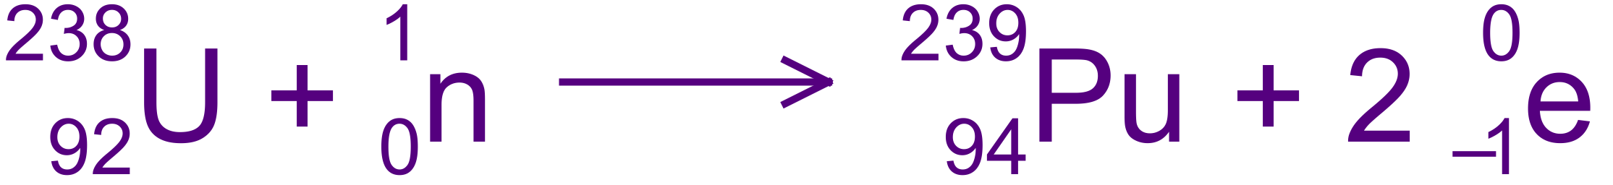

1. What is “enriched” uranium and why is it necessary to enrich it? (2 marks)

Enriched uranium has a greater level (higher percentage) of U-235 than the natural level [1]

If there is not enough U-235 present in the fuel rods the fission reaction cannot be sustained [1]

1. Chain reactions are controlled by using neutron absorbers. If these were not in place, an uncontrolled chain reaction could take place if the uranium was at critical mass. What is critical mass? (2 marks)

Critical mass is the minimum mass of a fissile material [1] required to sustain a chain reaction [1]

1. Why do fast neutrons need to be slowed down in a nuclear reactor and what is used to do this?

(2 marks)

Fission of U-235 nucleus will not be involved if the colliding neutron has too much kinetic energy (velocity) [1]

A moderator is used to slow the neutrons [1]

End of Test

